**DAILY ONLINE ACTIVITIES SUMMARY**

|  |  |  |  |  |  |  |  |  |
| --- | --- | --- | --- | --- | --- | --- | --- | --- |
| **Date:** | **02/06/2020** | | | | | **Name:** | **SPOORTI S DAROJI** | |
| **Sem & Sec** | **4th SEM. & ‘B’ SEC.** | | | | | **USN:** | **4AL18CS088** | |
| **Online Test Summary** | | | | | | | | |
| **Subject** | | **-** | | | | | | |
| **Max. Marks** | | **30** | | **Score** | | | **-** | |
| **Certification Course Summary** | | | | | | | | |
| **Course** | **Step Into Robotic Process Automation** | | | | | | | |
| **Certificate Provider** | | | **GUVI** | | **Duration** | | | **1 Hrs.** |
| **Coding Challenges** | | | | | | | | |
| **Problem Statement 1: Write a Java program to find Perfect Sum Problem.**  **Problem Statement 2: Write a program in java, an array of integer data to be initialized. During the initialization, if a user enters a value other than integer value, then it will throw InputMismatchException exception. On the occurrence of such an exception, your program should print “You entered bad data.” If there is no such exception it will print the total sum of the array.** | | | | | | | | |
| **Status: Executed.** | | | | | | | | |
| **Uploaded the report in Github** | | | | | **Yes** | | | |
| **If yes Repository name** | | | | | [alvas-education-foundation](https://github.com/alvas-education-foundation)/[spoorti_daroji](https://github.com/alvas-education-foundation/spoorti_daroji) [spoorti_daroji](https://github.com/alvas-education-foundation/spoorti_daroji)/coding_solutions/ | | | |
| **Uploaded the report in slack** | | | | | **Yes** | | | |

**Online Test Summary:**

**No internals conducted today.**

**Online Certification course Summary:** **Robotic process automation (RPA) is the use of software with artificial intelligence (AI) and machine learning capabilities to handle high-volume, repeatable tasks that previously required humans to perform. These tasks can include queries, calculations and maintenance of records and transactions.**

**In today’s session I learnt about Robotic Process Automation.**

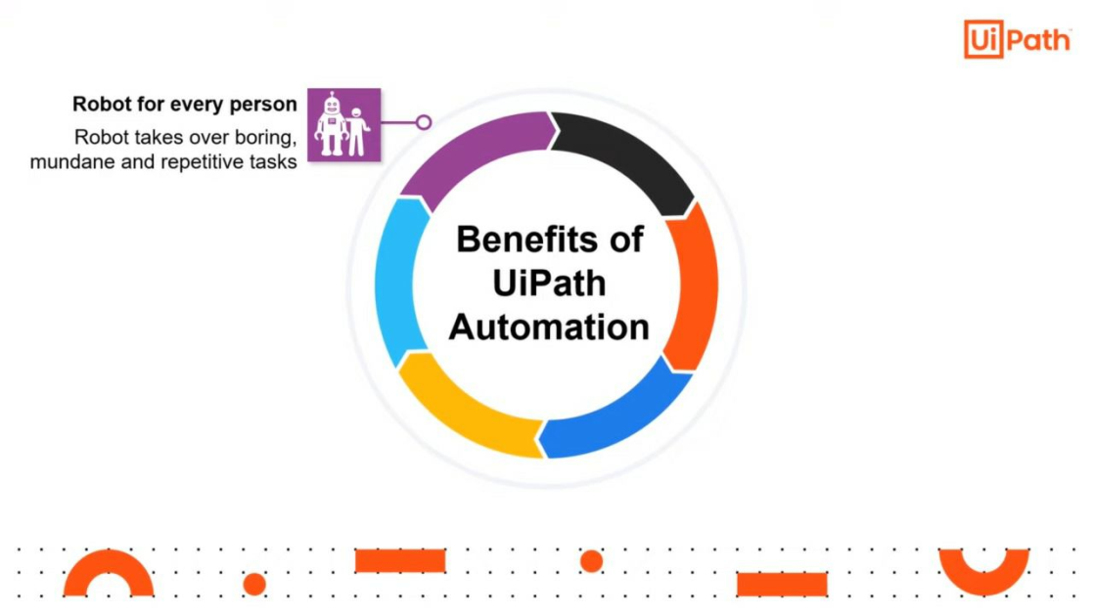

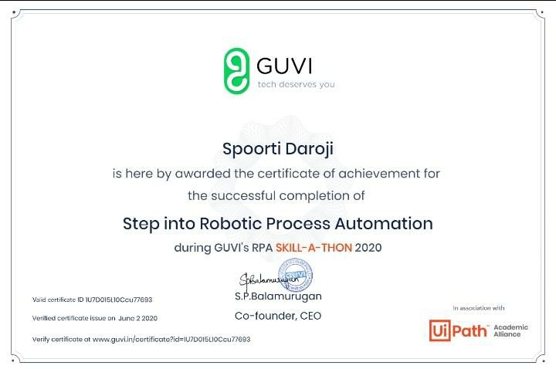

**Online Coding Summary: Today I had received one program from prof. Shilpa CSE Dept. the other from Prof. Reena Lobo CSE Dept. and Prof.Venkatesh CSE Dept. The program is mentioned above in the coding challenges (pg.01). I have also uploaded it to my Github repository, as shown below.**

* **Program to find Perfect Sum problem.**

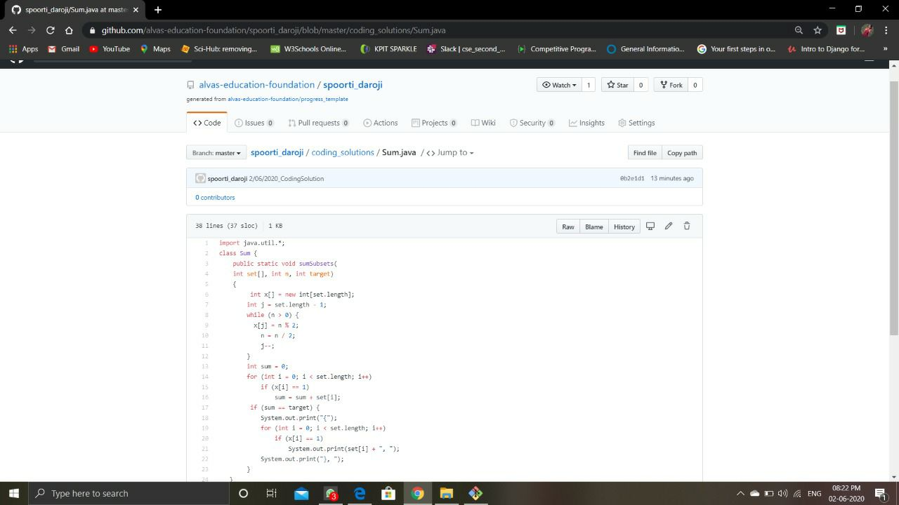

* 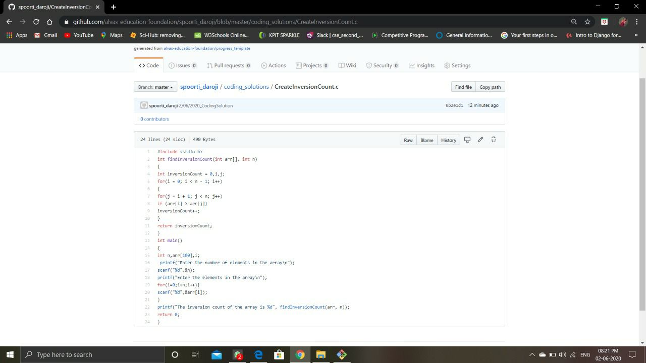**Program to find Inversion Count**